## IFT544: Middleware Prog & Database Sec (2023 Fall)

Sai Kishore Reddy Konatham

# Module 2 Assignment: JavaScript language

Prof. Dinesh Sthapit

September 3, 2023

#### 

# **Module 2 Assignment: JavaScript language**

**Introduction to JavaScript -1**

const message = 'Hello There';

console.log(message);

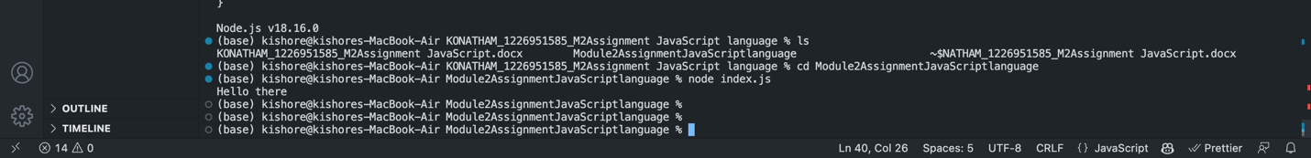

**With Function ( ) :**

**JavaScript Function Refactoring 2:**

**JavaScript Refactoring 3**

**JavaScript Variables 4**

**JavaScript Objects 5**

**JavaScript Parameter (Function as a parameter) 6**

**JavaScript Master Document Reference (required) 7**

<https://developer.mozilla.org/en-US/docs/Web/JavaScript>

**JavaScript Objects II 8**

**JavaScripts Arrays 9**

**Accessing Elements of JavaScript Object Arrays 10**

